**XML Descriptor – My first WORD ADDIN!**

**Keywords:** XML Descriptions, XML elements, XML mapping pane, content control titles and tags, content control properties,

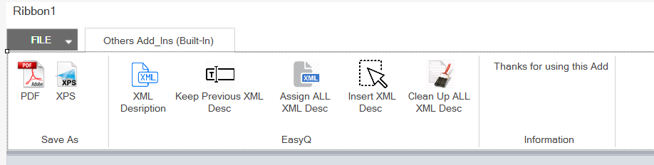This project was my first Add for Microsoft Word.

It contains:

1. Trial buttons to change the format of the document into **PDF** and **XPS**
2. My Goal buttons to modify the **tag** and **title** of the **XML Mappings**
   1. **XML Description** – it intended to copy the name automatically every time that you map a new content control. **Not working** – reason: there is no event that contains the name of the XML element when you map a new content control.
   2. **Keep Previous XML Desc Toggle** – it works together with the Assign All XML Desc. If the toggle is not checked, all the previous titles and tags will be overwritten.
   3. **Assign ALL XML Desc** – the titles and the tags of all the content control mapped in the document, header and footer will be filled with the name from the XML element in the XML Mapping pane.
   4. **Inser XML Desc –** Only the content control selected will be filled.
   5. **Clean Up ALL XML Desc** – All the content controls titles and tags will be deleted.

**Example: XML Element creator filled with one click!**

